- Analysis of all the visualizations to find out how it is helping you to find the Key Performance Indicators and the causes of various problems
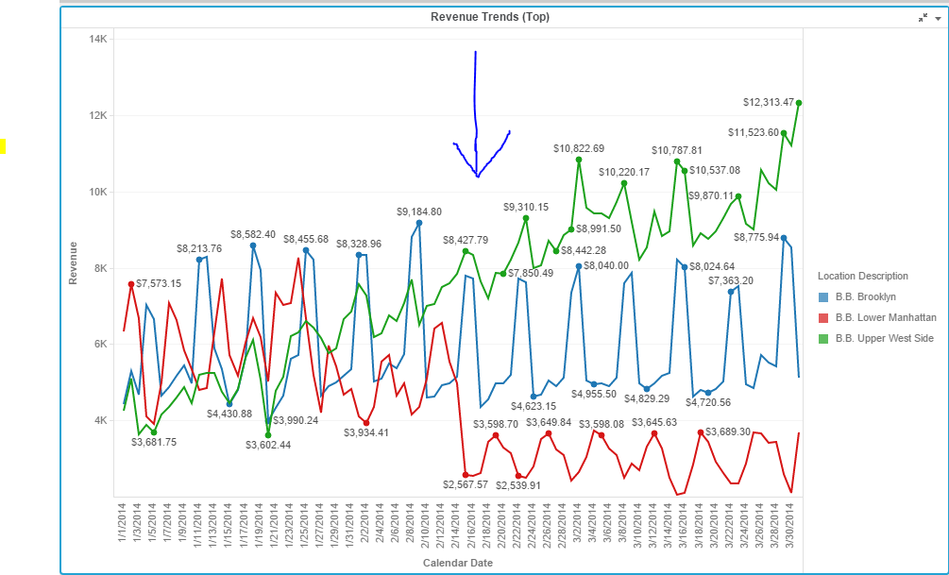

This graph helps us observe the revenue trend for these locations.
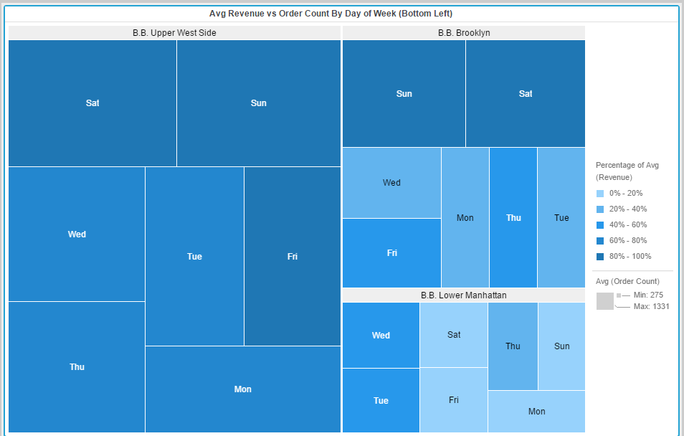

We can see that In Lower Manhattan, size or order count is least and has most light blue color (Least revenue
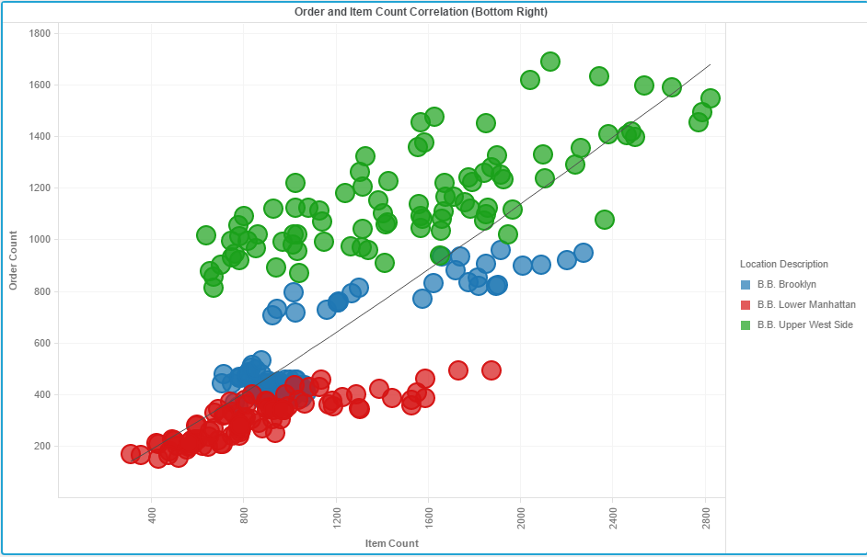

The Third visualization (Bubble Chart), shows the correlation between the Order and item count. We can see a trend line along 45 degrees, Green color dots of Upper West Side are mostly above the Trend Line , that means almost always order count is above line in Upper West Side.
The above three graph visualizations make it clear that:
- Restaurant at B.B.Upper West Side is performing the best.
- Restaurant at B.B.Lower Manhattan is performing the worst.

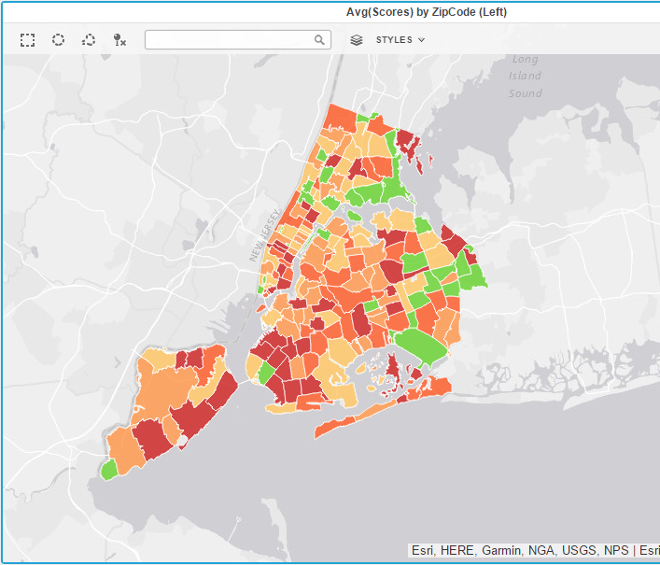
We plot NYC Health Inspections in map by zip codes to have an overview of the regions. Green Color have lowest score and Red have the higher scores.
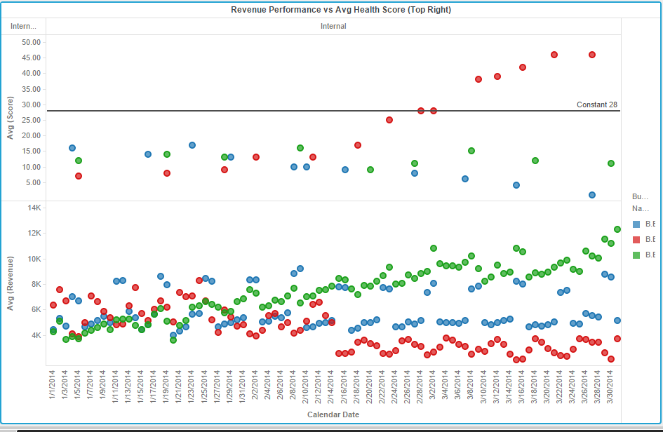

We now see that health score affects the revenue at three locations.Avg(Score) is most for Red(Lower Manhattan) is correspondingly it has lowest revenue.Inpection above Reference Line of 28, receives C Grade and we see red dots are above that line.
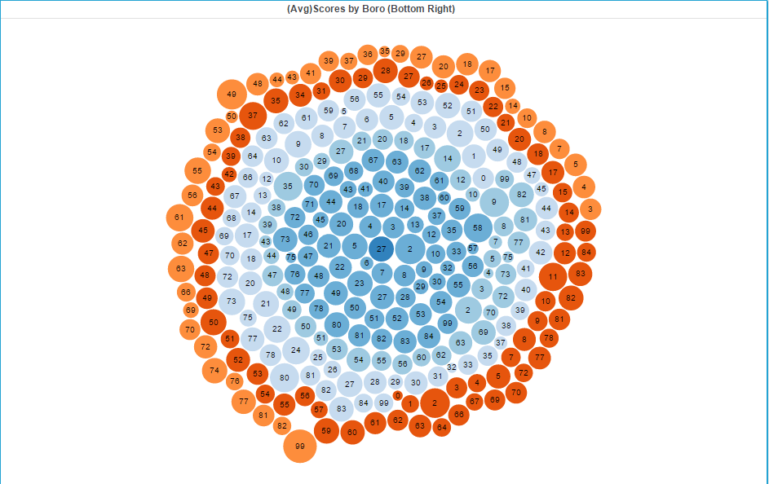
Above D3 Graph helps us to find whether there are any cuisines that fare good across multiple boro’s.

- What more could you have done other than what is included in the exercise to achieve better analysis of both the datasets?
We can plot a bar graph, trying to find out the Average value of Revenue on different week days.
We can clearly see that Upper West Side restaurant gets most revenue on Saturday and Sunday.
We should try to attract customers in Lower Manhattan on Saturday and Sunday by giving some offers and discounts.
